TASK 4

3) Perform OLAP operations

a) Drill Down

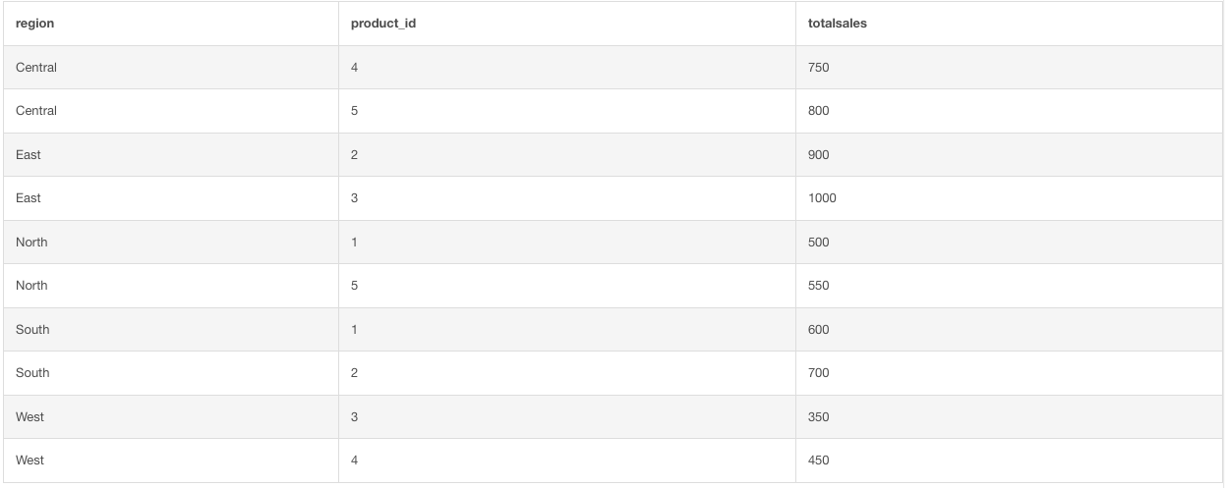

b) Rollup

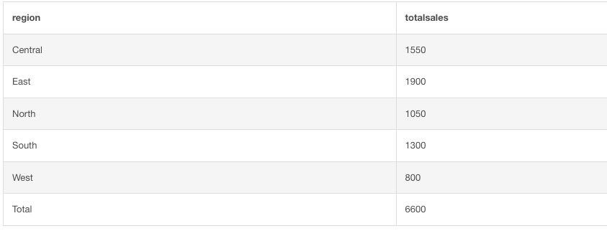

c) Cube

1

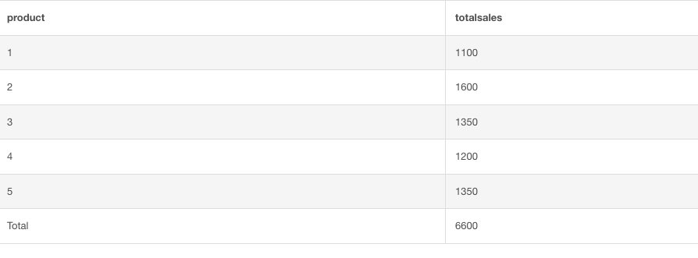

2

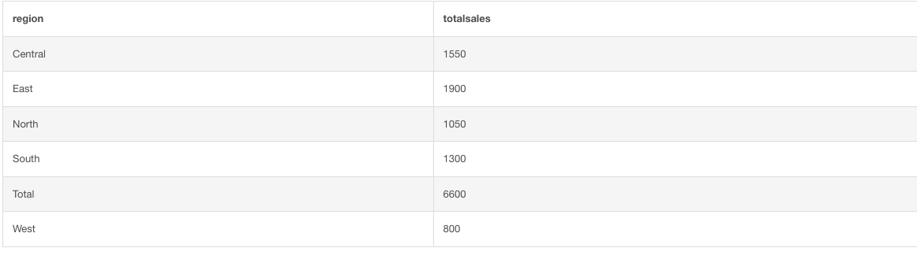

3

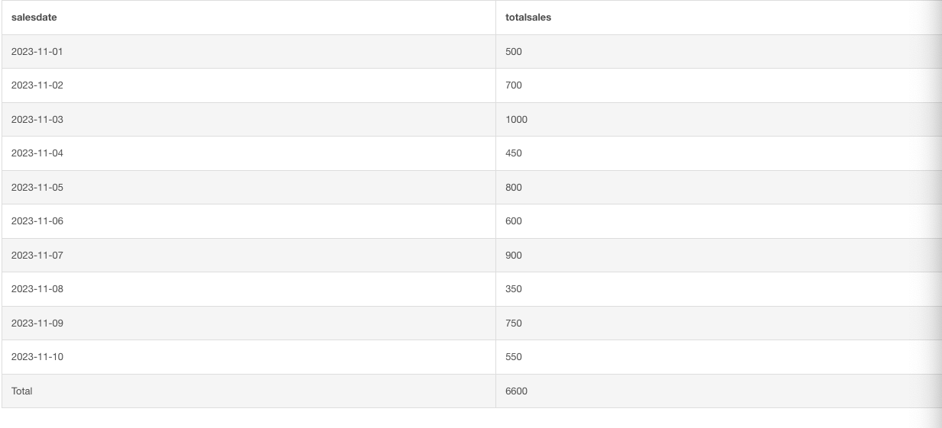

d) Slice

1

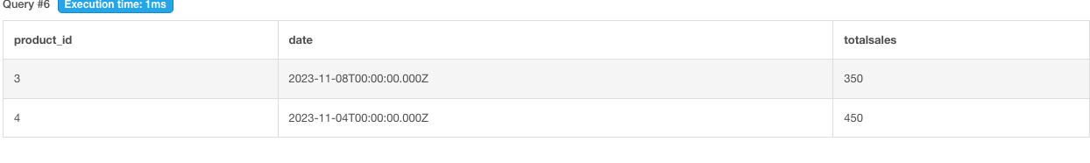

2

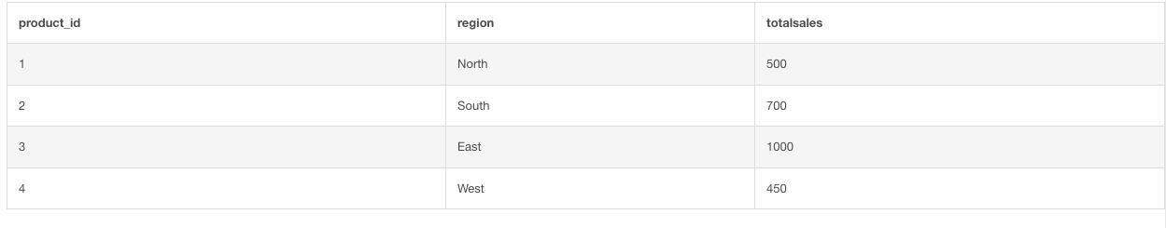

e) dice

